Shabbos Stories for
Parshas noach 5783
Volume 14, Issue 7 – 4 Chevron 5783/October 29, 2022
Printed L’illuy nishmas Nechama bas R’ Noach, a”h

For a free subscription, please forward your request to keren18@juno.com
Past stories can be found on the website ShabbosStories.com
The Rav of Metz
By Rabbi Shimon Finkelman

One day, a delegation from Metz, France came to the Baal HaPardes’ home to offer him the rabbinic post in their city. Such luminaries as the Pnei Yehoshua and R’ Yonasan Eibeschutz had served as rabbanim of Metz. With the passing of R’ Shmuel Hellman, the delegation was seeking a new rav.
The Baal HaPardes refused their offer, but suggested whom he thought was an even better candidate. He introduced them to his guest, R’ Leib, famed author of the Shaagas Aryeh. The Baal HaPardes considered it a Divine act of Heaven that the delegation visited his home just when R’ Leib was staying with him.
The delegation was not prepared for this turn of events. They had all heard of the Shaagas Aryeh, and felt privileged to simply stand in his presence. R’ Leib detected that the delegation was concerned about his advanced age, fearful that his tenure would not last long.
He told them, “I understand your fears. Seeking a rav is a difficult task and you would not want to go through it again in the near future. The loss of a rav, which you have recently suffered, can also be devastating to a community.”
The delegation was amazed at R’ Leib’s insight and understanding. He then asked, “How long a tenure would you consider satisfactory, were I to become your rav?” Taken aback by the question, they conferred and replied, “Fifteen years would be a satisfactory length of time.”
R’ Leib’s response was even more shocking than his question had been. “You have nothing to fear. I will lead your community for more than 15 years.” A few days later, a joyous delegation escorted R’ Leib to Metz. He would reside there for the rest of his life. (The Story of the Shaagas Aryeh)

Reprinted from the Parshas Ki Seitzei 5782 email of The Weekly Vort.

The Chassidic Rebbe’s Questions to the Mother
Of a Very Sick Child

A woman came to a Chassidic Rebbe known for the efficacy of his blessings with a compelling request: Her only son had been diagnosed with leukemia. The doctors had given him a grim prognosis. Unless a miracle were to occur, he would succumb to the illness in a few months. The mother trembled with fear as she pleaded with the holy Rebbe to intercede in her behalf, so that the decree would be annulled. Tears rolled down her cheeks as she begged the Rebbe for a blessing.
The Rebbe looked at the woman and asked, “If you knew that it was Hashem’s will that your son succumb to this disease, would you be willing to let go, to let your son die? Could you give up your son if you would know that Hashem wants him?”
The distraught mother just sat there and looked at the Rebbe, while a multitude of thoughts and emotions went through her mind. Finally, she replied, “Rebbe, if I knew for certain that it was Hashem’s Divine will that my son die, I would be willing to give him up!”
The Rebbe listened to her, nodded his head, and said, “Now we can pray for your son.” He then offered a prayer on behalf of the boy, submitting him completely to the wisdom and mercy of Hashem.
Three days later, the boy was released from the hospital – with a new lease on life. He is now a grown man. Faith and trust go beyond ordinary belief. They call upon us to develop our relationship with Hashem as the silent (managing) partner in our lives.

A Serious Leg Infection
The following story is a classic example of this idea. Horav Leib Gloiberman, zl, was a saintly Yerushalmi. He merited to be among the close students of Horav Yisrael, zl, m’Stolin. During his twilight years, he came down with a serious infection in his leg. This was before CT and MRI scans.
Thus, doctors employed their expertise, based upon experience, to render medical decisions. They determined that unless Rav Leib’s leg were to be amputated, he would die as the result of the infection spreading to the rest of his body.
The surgery was scheduled. During the procedure following the actual amputation, one of the surgeons came out to talk to the family. Apparently, after thoroughly examining the amputated leg, it was determined that the surgery had not been necessary. Understandably, what had happened could not be reversed.
Rav Leib had lost his leg. When Rav Leib woke up from the anesthesia, a member of his family was with him to check on his recuperation from surgery. He did not think before he spoke, and he blurted out that it had all been a mistake; the doctors’ diagnosis was erroneous. He never should have lost his leg.

The Words of an Apikoris (Heretic)
When Rav Leib heard these words, he declared, “These ears (pointing to his ears) heard from my venerable Rebbe, Volt ich, zolt ich, ‘If I would have done this, or if that would not have happened to me (the results would have been different) is an apikores, heresy!’”
By asserting that things an apikores, heresy!’” By asserting that things could have ended differently, he intimates that Heaven had no hand in his achievement – negative or positive. “In their medicine manuals,” he added, “they could write that a leg that has such an infection does not require amputation. According to the Heavenly diagnosis, however, my leg obviously required amputation; proof positive is that it was amputated (by mistake). This is what Hashem wanted. The subject is closed.”
This story provides us with a clear perspective of the meaning of emunah in Hashem. The believer believes that whatever happens is orchestrated by Heaven for a reason beyond his ken. It is with ironclad faith that we are able to triumph over the minions of Eisav, Amalek – regardless of the name to which they presently answer.

Reprinted from the Parshas Ki Seitzei 57u82 email of Rabbi A.L. Scheinbaum’s Peninim on the Torah.

The Eternal Bowl of Soup
About a hundred years ago, a mother in a small European village finished doling out the meager bowls of soup which were all her family could afford. Just then, there was a knock on the door.
A poor(er) man entered and asked for something to eat. Before she could say anything, one of the children escorted the man to the table and gave him his own portion.
The man gratefully ate and left with blessings for the family for their kindness. When he had gone, the mother asked her son, “You know I have no more soup to give you. Why would you give it away?”
“If I had eaten the soup,” replied the boy, “what memory would there be of it in two hours? I’d be hungry again anyway and the soup would be gone forever. Now, the mitzvah I did with that soup will live on forever and never be forgotten.”
Not only did that mitzvah live on in Heaven, but this man’s grandson is deeply involved with a charity organization which feeds thousands of Jewish people each Shabbos. Indeed, many days of many lives were lengthened because of his thoughtfulness.

Reprinted from the Parshas Ki Seitzei 5782 email of Jonathan Gerwitz’s Migdal Ohr.
21 Years After Miraculous Escape From 9/11 Catastrophe, R’ Shmuel Katz Passes Away
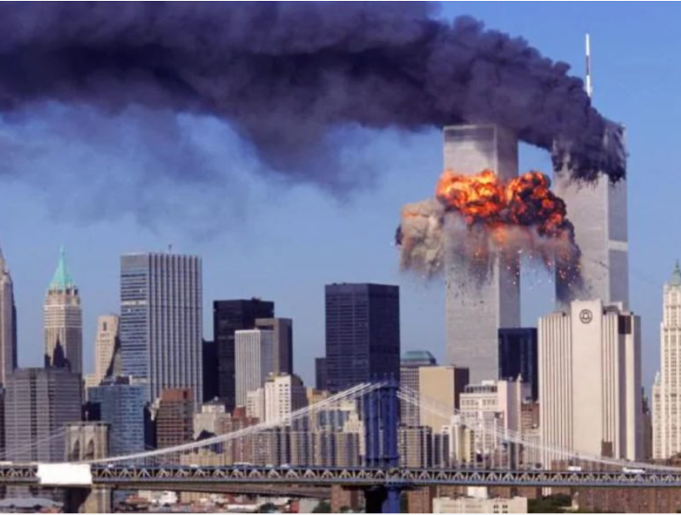

NEW YORK (VINnews) — R’ Shmuel Katz used to work on the 85th floor of one of the Twin Towers. Every day he would make his way to Manhattan on the subway but was distressed by being forced to sit in the crowded rush hour trains in which many people were dressed in immodest attire.
R’ Shmuel begged his supervisors to allow him to come to work two hours later daily and work later hours at the end of the day in order not to have to contend with the rush hour trains. The supervisors, seeing his industriousness and diligence, agreed to give him a special permit to arrive late.

The permit proved to be a lifesaving device, because when the Twin Towers were blown up by terrorists on 9/11/01 (23 Elul 5761), R ‘Shmuel (as well as many other orthodox men who were saying slichos) had yet to arrive at his workplace and was therefore saved from the cataclysm which killed 2,977 people.
This week, 21 years later, R’ Shmuel Katz passed away, after having merited married off all of his children. The children told the story of their father’s special salvation and Rabbi Elimelech Biderman mentioned the story in his weekly shiur.

Reprinted from the September 11, 2022 website of VINnews.

The Power and Importance
Of Answering Amein

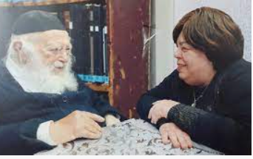
Rav Chaim Kanievsky and Rebbetzin Batsheva Kanievsky

Rav Chaim Kanievsky and his Rebbitzen, zt”l, had the custom to say Birchas HaShachar together each morning. Rebbitzen Kanievsky once explained how this began. “One day, a young man told me that he dreamt about a dear friend, Reb Horowitz, who learned together with Rav Chaim in the Kollel Chazon Ish.
Reb Horowitz, who had passed away at a young age, appeared to him in the dream and told him that in Shamayim they’re extremely strict when people make light of answering Amein, and are not careful with this in general.
I heard this story and I determined that I have to do something about it. I decided, together with the women who Daven in the Lederman Shul, that each one of us will arrive at Shul before Davening, and say Birchos HaShachar together out loud. Everyone will answer Amein to each other’s Brachos, and we will be Zocheh to recite Amein many times at the beginning of the day.
“Baruch Hashem, as time passed, the number of women who arrived early to Davening began to increase, and many women were Zocheh to answer Amein to the Brachos. One day, my grandson, who is also the grandson of Rav Shteinman, zt”l, came to visit, and I told him about the women answering Amein. My grandson was very moved and he told Rav Shteinman about it.
“Rav Shteinman was also moved by the story, and he asked the young men in the Minyan he had in his home to arrive early for Davening and say Birchos HaShachar out loud. Also, Rav Chaim, who heard about the dream with Reb Horowitz, calls me over every day before I leave to Shul, and says Birchos HaShachar for me, in order that we can be Zocheh to say Amein. Once Rav Chaim started saying the Brachos, I also said Brachos at that time as well!”

Reprinted from Parshas Ki Savo 5782 of Rabbi Yehuda Winzelberg’s Torah U’Tefilah.

The Responsibility of a Rav

A Talmid Chochom was once offered a position as a Rav, and he came to the Chofetz Chaim for advice. The Chofetz Chaim discussed all the general obligations of a Rav, and then added, “Let me tell you one more responsibility that a Rav has.
“For a brief time, I served as Rav here in Radin. During that time, the local Shochet was caught selling non-kosher meat, and was removed from his position. He later came to me, destitute and apologetic, promising never to do it again, if I would only help him to regain his position.
“I agreed on condition that he undertake to donate candles to the Shul. Everything went well from that point on, until the Shochet died. Shortly after his Levaya, I had a dream in which three Rabonim came to me, and asked about my instruction to the Shochet that he donate candles to the Shul.
“They inquired if I intended it to be a K’nas, a penalty for his terrible Aveirah, or a form of Kaparah, atonement for it. I replied that I had intended it to be as a K’nas, a type of punishment.
“The next night, the Shochet came to me in a dream. He was crying. He explained to me how he had been arguing in Shamayim, in the Bais Din Shel Ma’alah, that the candles he had donated had already provided him with a Kaparah, and he was absolved from his Aveirah, but because of what I said, the Bais Din had decided that he still required a Kaparah, and he needed atonement.
Imagine!” explained the Chofetz Chiam. The Bais Din Shel Ma’alah would have forgiven him if only I had said that the candles were a Kaparah! Such is the responsibility of a Rav!”

Reprinted from Parshas Ki Savo 5782 of Rabbi Yehuda Winzelberg’s Torah U’Tefilah.
The Inspiration
To Do Teshuvah

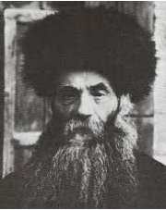
Rav Isser Zalman Meltzer, zt”l, Rosh Yeshivah of Yeshivah Eitz Chaim in Yerushalayim, was invited to the Bar Mitzvah of the son of a former student. It struck him that about 20 years had gone by since the Talmid himself had his own Bar Mitzvah.
He said to the Talmid, “Thank you.”
The student was confused and asked his Rebbe why he was thanking him.
Rav Isser Zalman said, “Seeing you made me ask myself, ‘What have I done with my last 20 years?’ It made me start to think and retrospect, and I had an inspiration to do Teshuvah for not doing enough with the time Hashem gave me. Because of you, I had the merit of doing the Mitzvah of Teshuvah!” Rav Isser Zalman was careful to show appreciation to others even for indirect benefits he received from them!

Reprinted from Parshas Ki Savo 5782 of Rabbi Yehuda Winzelberg’s Torah U’Tefilah.
The Son of the Melamed

R. Meir Mordechai Chernin's father, R. Pinchas, was a chossid of the Mitteler Rebbe and a poor melamed who had taught Chassidus to the famed chossid R. Shmuel Ber Borisover. Before his untimely passing, he had R. Shmuel Ber promise to direct his son Meir Mordechai in the ways of Chassidus.
When Meir Mordechai was sixteen years old, he attended the yeshiva in Minsk, and began to disassociate from chassidim. R. Pinchas then came to R. Shmuel Ber in a dream and reminded him of his promise.
When Meir Mordechai next visited Borisov, R. Shmuel Ber handed him a note his father had written before his passing: "I am now going in the way of the world. You, Shmuel Ber, remember your faithful promise that when my son grows older, you will repay my debt and learn with him divrei elokim chaim, Chassidus, and guide him in the ways of Chassidus as I taught and guided you. And you my son Meir Mordechai, when you start learning Chassidus, come to my grave and notify me."
Indeed, for the next ten years, Meir Mordechai learned Chassidus from R. Shmuel Ber and became a great chossid. R. Meir Mordechai held dearly onto the note, and the Rebbe Maharash said of it, "These few lines express the shining countenance of a chassidisher melamed and guide." )רשימות דברים חדש ע' 251 ,התמים ח"ז ע' 102 ,ס' התולדות ריי"צ ח"א ע' 100)

Reprinted from the Parshas Ki Seitzei 5782 edition of The Weekly Farbrengen.

The Father’s Dramatic Response to His Straying Son

R. Hillel Chernin, R. Meir Mordechai's son, related to R. Foleh Kahn: As a youngster, I strayed from the path of Torah. My father would rebuke me, but I didn't listen. During a yechidus with the Rebbe Maharash, my father bemoaned my conduct and remarked, "If Hashem caused him to break his leg or the like, maybe he'd change his ways."
“A short time later, I was hit by a wagon and wounded my leg. The pain was intense, and puss poured from the wound. It got increasingly worse, and the doctors couldn't heal it.
"Nu! Will you improve yourself now?" my father said. "If you do, I will ask the Rebbe for a bracha and you will recover."
“I gave my word and changed my ways. My father traveled to Lubavitch and received the Rebbe's bracha, and I healed completely. Time passed and the Rebbe Maharash passed away, and I began to stray again. After warning me first, my father went to the Rebbe's Ohel and wrote a pan notifying the Rebbe that I had strayed, and asking the Rebbe to retract his bracha.
“Even before my father arrived in Vitebsk, the pain returned to my legs and puss again poured from that place. I committed to improve, and my father returned to the Ohel to daven for a bracha, after which I healed again. Many decades later R. Hillel shared, "Ever since then, whenever I am strong in Yiddishkeit, I am perfectly healthy. But when I slide somewhat, I start to feel it in my legs." )שמועות וסיפורים ח"א ע' 74

Reprinted from the Parshas Ki Seitzei 5782 edition of The Weekly Farbrengen.

A Question of Merit
By Rabbi Paysach J. Krohn

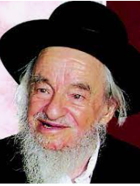
Rabbi Yaakov Galinsky
R' Yaakov Galinsky, a noted orator in Israel, was once asked to address a group of ba'alei teshubah (repentants) in Bnei Brak. In the audience was a writer from the secular Israeli newspaper, Maariv. Although he was not religious, the writer had come to the speech in order to interview some of the assembled people and get their views on the new way of life they had chosen.
After the speech, the writer approached one of the ba'alei teshubah, a man in is thirties, and asked him, "Who will get more merit in the World to Come: you (who have come back to authentic Judaism) or the children here in Bnei Brak (who have been religious all their lives)?"
At that moment R' Yaakov happened to be walking by and overheard the question. He stopped and stood near the two, wanting to hear what the reply would be. He was sure that the man would cite the well-known Talmudic teaching (Sanhedrin
89a) which implies that ba'alei teshubah are regarded as being on a higher level than even those who have been righteous all their lives, thus according them more merit in the World to Come. However, what the gentleman actually replied startled R' Yaakov.
"The boys here in Bnei Brak will surely get more reward than I will," said the man with confidence.
"But why is that?" asked the writer.
"I am one who is compelled," the ba'al teshubah replied. "I have seen the outside world and I know it is one of emptiness, vanity and falsehoods. I was thus compelled to come to the truth, which is the practice of authentic Judaism. These children, though, still think there is a world of attraction out there - and yet they cling to their beliefs!" (Around the Maggid's Table)

Reprinted from the Parshat VaYelech 5781 email of Rabbi David Bibi’s Shabbat Shalom from Cyberspace.

The Talmud Chacham
And the Innkeeper
A Midrash tells the following story. A talmid chacham (Torah scholar) was traveling with an innkeeper when they met a poor, blind man collecting money on the outskirts of a city. The talmid chacham gave tzedakah, and he urged the innkeeper to do the same, but the innkeeper replied, “You know him, so you gave him tzedakah. I don't know him, so I won't give him anything.”
They walked further, and the Malach Hamavet appeared to them and said to the talmid chacham, “You gave tzedakah, so your life will be spared, and you’ll live another fifty years.” Then he turned to the innkeeper. “But your final day has arrived.” The innkeeper begged, “Let me give tzedakah now!” But the Satan explained to him that it was too late. He had lost his opportunity.
The innkeeper, stoic, said, “Before you take me, just allow me to praise Hashem for all the kindness He has done for me throughout my lifetime. Then I will come with you.” The Malach Hamavet paused and then decreed, “Since you want to praise Hashem, years have been added to your life. You will not be going with me today.”
We learn from this story the great benefit of counting Hashem’s kindnesses. Yes, tzedakah is lifesaving, and we should aspire to give as much charity as possible. However, praising Hashem for His infinite chessed can offer a great amount of protection as well.
Reprinted from the Parshat Ki Tavo email of Jack E. Rahmey based on the Torah teachings of Rabbi Amram Sananes.
A Life-Changing Conversation

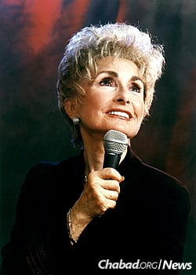

One of the first and most successful kiruv organiztions in the U.S. is Hineni, founded by the dynamic Rebbetzin Esther Jungreis a”h in the 1970’s.
The organization was an instant success and the Rebbetzin was asked to speak and engage with people at many events all over the world. She recalls one very special event that she was asked to speak at.
One day, she received a call from Shlomo Levin, the Israeli consul in New York. He said, “Rebbetzin, I heard you speak at Madison Square Garden in NYC, and I think that our troops in Israel would greatly benefit from your message.”
Shlomo had sent a publicity shot of Rebbetzin Jungreis, mike in hand, taken at Madison Square Garden, to the Israeli Army Entertainment Corps, and they mistakenly thought that she was a singer.
Some weeks later, she received a call from army headquarters in Tel Aviv asking how many performances she was prepared to do. She was so moved by the fact that they had invited her to speak - or so she thought - that she had difficulty finding words, and in a voice choked with tears, she accepted.
Well, it took some clearing up before the army agreed to do a half hour of music before she gave a speech to the troops. With great Siyata D’shmaya, she found a band from Miami willing to play for free for a half-hour, and although she didn’t know how they played, she trusted that all would be well. In fact, it went even better than expected and the band was great.
She became an overnight success in Israel. Invitations began pouring in from army bases as well as from the municipalities of Jerusalem, Tel Aviv, and Haifa. Her plan had called for a ten-day tour, but the pressure was on to extend her visit.
There was just one problem: the musicians from Miami had to return to the States, and there was no one to replace them. “Don’t worry,” her husband R’ Meshulem Jungreis zt”l, told her, “Hashem will send you someone!” And He did!
That Friday eve, as she sat in the dining room of her hotel in Jerusalem, the maitre d’ came over to inform her that there were some yeshiva boys in the lobby who wanted to speak to her.
“Rebbetzin,” one of the older boys said, “we are yeshiva students and we have our own band. We came to welcome you to Jerusalem and to offer our services.”
“That’s wonderful,” she said. “How did you know I needed a band?”
“Well, actually, we didn’t know. We just wanted to participate and help.”
He looked at the Rebbetzin and continued, “But there is another reason as well. A few years ago, I lived in New York. I was totally assimilated. I had no understanding of Judaism. My life was music, and I was on my way to Paris to continue my musical studies.
“I was walking on Kings Highway in Brooklyn when suddenly I heard a crash and the screech of brakes. I looked up, and there in the street, covered with blood, was a rabbi who had been run over by a car. I rushed to his side and tried to talk to him, but he didn’t respond, so I stayed with him and held his hand until the police and an ambulance arrived.
“As he was lifted onto a stretcher, I noticed that his lips were moving. It seemed like he wanted to tell me something. I leaned down and bent my ear close to his lips to hear him. Rebbetzin, you’ll never believe what the rabbi said to me.”
For a moment, the young man paused. Then he swallowed hard and continued his story. “‘Are you Jewish?’ the rabbi asked me in broken English. ‘Yes,’ I answered. ‘I am Jewish.’ The rabbi whispered again, although it was obvious that it was very painful and difficult for him to talk. He mustered all his strength and said, ‘You must go to Jerusalem and study Torah!’”
“Can you imagine? Here was a rabbi, suffering from multiple fractures, his body bloody and bruised, and in his pain what does he say? He tells me to go to Jerusalem and study Torah! That experience changed my life. I realized I had met a saint, a man who was so committed to his faith that he was able to overcome his suffering to reach out to me. So now you know why I’m here.
“That rabbi was your father, R’ Avraham Jungreis zt”l! The rabbi saved my life, and I want to give back.”
Rebbetzin Jungreis was stunned. She knew the story of her father’s car accident. When he recovered from that accident, he told her of the incident and asked her to try
to find the young man and thank him for his kindness in staying with him until the ambulance came. She had never located him - until now, years later, in Jerusalem - this assimilated boy turned yeshiva student came to thank her and offer his services in gratitude, and she was able to thank him in the name of her father.
Reprinted from the Parshas Ki Savo 5779 email of Rabbi Dovid Hoffman’s Torah Tavlin.

Gratitude for the
Rotten Orange

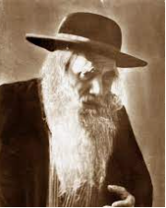
The advent of violence, hatred and incitement against Jews living in Eretz Yisroel did not begin with the State of Israel in 1948.
For many years before, the Arabs had been fomenting acts of violence against the small Jewish population of Palestine who lived in a few select cities.
After the massacre of 1929, R’ Yosef Chaim Sonnenfeld zt”l, chief rabbi of the old Yishuv in Jerusalem, issued a touching appeal to the Arab population to live in peace with the Jewish community, assuring them that the Jewish people had no secret plans to take their mosques or any other Arab properties.
On one occasion, R’ Yosef Chaim was walking to the Kosel Hamaaravi accompanied by another Jew. An Arab storekeeper noticed them, and threw a rotten orange at them.
R’ Yosef Chaim turned to the Arab and exclaimed, “Todah Rabba!” The Arab did not understand what he had shouted, and chased after them to find out.
The person accompanying him told the Arab that the rabbi had said “Thank you.”
The Arab was stunned and said, “Thank you? For what?” R’ Yosef Chaim replied, “Thank you for throwing an orange at me - and not a rock!”
The Arab was embarrassed at what he’d done to the holy rabbi and from then on, he would extend special honor to the chief rabbi whenever he passed his store.
Reprinted from the Parshas Ki Savo 5779 email of Rabbi Dovid Hoffman’s Torah Tavlin.

